Vulcan Activity Tracker
Weekly Report

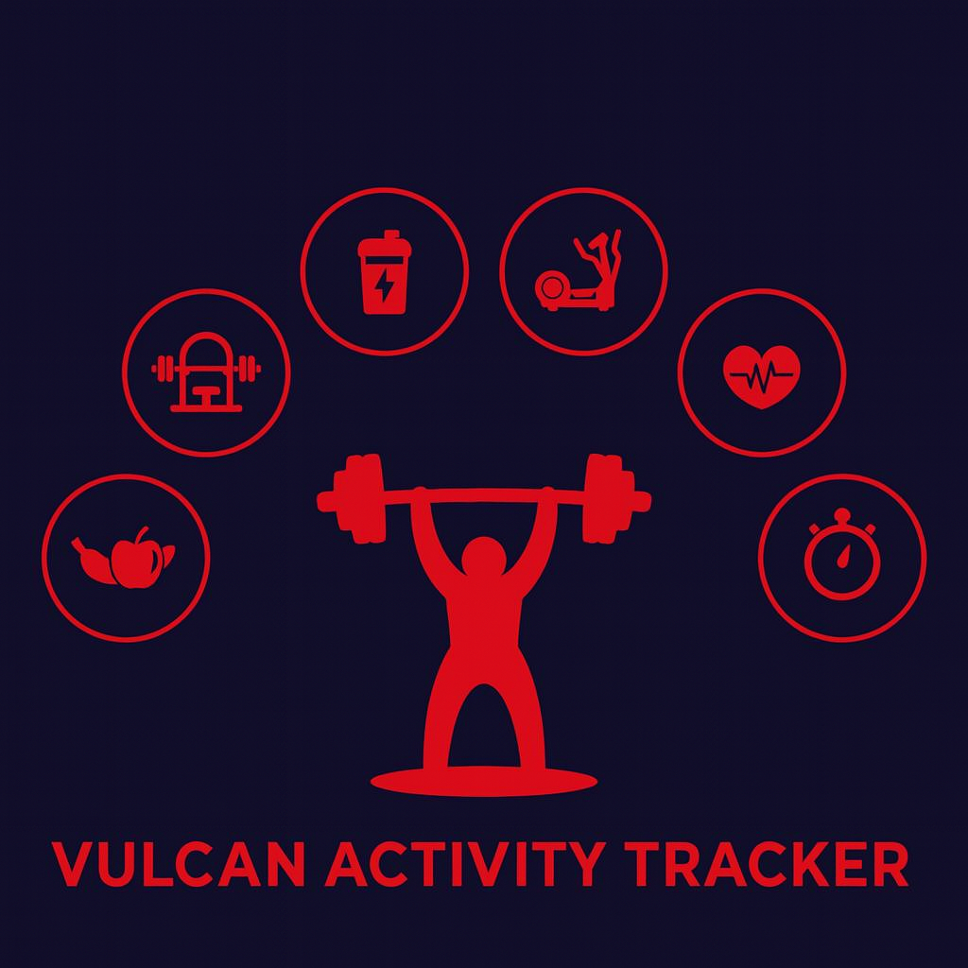

Week 3
Team Members:
Margo Bonal
John Gerega
Luke Ruffing

Professor:
Dr. Weifeng Chen

Course: CMSC-4920-Senior Project II
School: Pennsylvania Western University

Project: Vulcan Activity Tracker
To complete the proposed goals in previous week’s report, our team followed a strict schedule of daily progress and communication. Our team had 5 main goals to complete, Dashboard finalization, Activity Page creation and functionality, User data transfer, login bug corrections, and database schema creation. Since each goal needed time allocation for development and testing, we assigned each goal priority based on how they were connected to each other. Throughout the discussion, we decided Activity Page creation was the number one priority to accomplish at the start of the week. This is because most features are reliant on the User’s stored exercise or activity data. Creation of database schema and API architecture was included in this priority to make the feature fully work. Other tasks, such as correcting the user login bug, were set to lower priority since it didn’t majorly affect app access.
Goals Accomplished:
The first goal was to get a user-friendly frontend for users to upload various types of activities. This page has three fields of information that every type of activity will contain: the name of the activity, the date, and the duration of the activity in minutes. A dropdown menu of choices is available to the user, and the fields associated with their choice will appear once they have clicked on it. Once users are done, they click the "Save Activity" button at the bottom of the page to save their choices. Error checking is done to ensure that the required fields contain data.
The second goal was to take the data the user entered in the activity page and upload it into our backend database. To accomplish this, a new table was required in the database for activities, and the program had to extract the active username to ensure the new activity was uploaded to their account.
The third goal was to take the data just uploaded to the database and format it to be shown in a table on the activity page. To accomplish this, the second goal had to be implemented correctly, and then we had to successfully fetch the activity data from the database and place it into a JSON file in order to successfully place it into an HTML table element.
The final goals of this week were the finalization of the dashboard design and the correction of user login bug. Dashboard design was revised from the original formatting to a modular and modern style. Each component is designed with the user in mind. We wanted the environment to quickly respond to interactions. For example, dashboard buttons hover to show a user where their mouse is currently on the screen. Another major development for this week’s progress is this display of current logged in username on the dashboard page. This presented challenges in regard to user session storage management. User login bugs were additionally corrected. The resulting bug allowed a user to create an account with the same username as another user. However, this crashed the server side of the program since the database only allows unique usernames or one instance of that exact username. Login logic was corrected to check the database for unique usernames and display that a username was already in use.
Challenges faced:
In trying to accomplish the second goal, the team ran into some issues. We could not simply hard-code activity data into an API as the application accepts various types of activities with different fields (running, biking, sports, etc.). We had to model this data transfer in a modular way to accept different parameters/data and also display different types of data. This architecture was both tricky to plan and conceptualize since we wanted to maintain efficiency where we could. Additionally, the database storage of user exercise activity was quite challenging since every data field couldn’t have its own row in the table to prevent for massive schema architecture.
Solutions:
To fix this issue, we had to split the data into two categories: common data that every activity will have, and data specific to that type. Common data was extracted first, then the program ensures the activity-specific data is able to be serialized into JSON. To store all different types of data in the database, we used the organized categories to determine where data should go. Common data is assigned to a row in the database table. All other specific data is then stored as a list. When other parts of the program need to access these specific data fields, the list can be retrieved from the database and searched by specific label.
Team Progress:
According to our Group 2 Gantt chart, our team is ahead of schedule on the activity page since it was previously proposed for march development. However, we are exactly on schedule for dashboard development. Since the dashboard holds many components and it is the base of functionality, it will need to be allotted appropriate time for design and API connections for data display. Through initial steps of progress, our team has realized that the dashboard is reliant on the data that will be entered on other pages of our application. This means that certain tables and charts on the dashboard will need to be set aside to wait for further development of other page features. Our team has noted that this means that each page and data entry point will need to be thoroughly tested to ensure proper results when it is time to fill in the dashboard charts with our stored user data. Data filtering and validation will be harder at a later date in the process if not set up correctly now.
Gantt Chart:
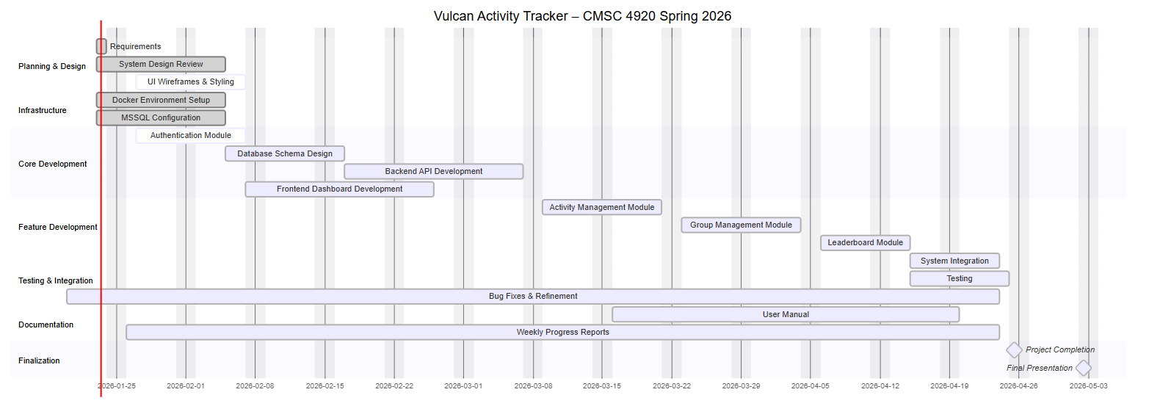
Week 3 Plan:
This week, our senior project team will continue progressing on key features that are fundamental pieces to other components. This development will be seen in the progression of the dashboard, leaderboard page, and club’s page. Additionally, we would like to display user activities on the dashboard that were stored in the database from the Activities Page. Consistent styling will be used across all pages to create an immersive environment for users. Each component will be designed for clarity and accessibility. Data filtering and validation will be applied to user data entry points as long as pre-checks before database insertion. Overall testing and bug fixes will be done as well. We propose that week 3 will be a productive week to move our project a step closer to the end goal!

Member Contribution:
Margo Bonal:
- Dashboard design
- Activity Page Design
- Activity API, Schema
- Fix unique username error
- Team meetings, Week 3 Report & Slides
John Gerega:
- Activity Page
- Leaderboard Page
- Team meetings, Week 3 Report & Slides
Luke Ruffing:
- Clubs Page
- Team meeting

